Post combustion CO2 capture can be broken into three parts.

1. Flue gas cooling and compression
2. Absorbtion og CO2 and regeneration of solvent
3. CO2 compression

**Flue gas cooling and compression:**

The absorber in the MEA system operates at a temperature of approximately 40°C and

hence, the inlet temperature of the gases to the absorber system needs to be around 40-

50°C. In the case of natural gas combined cycle plants (NGCC), the temperature of the

flue gas at the exhaust of the power plant is around 110-120°C and these gases need to be

cooled before being fed to the absorption system.

The flue gas is typically cooled by passing it through a direct contact cooling tower

(DCC). The DCC is a packed tower in which there is counter-current flow of cooling

water and the flue gases. The flue gases enter at the bottom of the tower with the cooling

water entering at the top. In the tower, the flue gas is cooled by evaporation of water and

hence, the water content of the flue gas is reduced at the exit of the tower. The cooling

water is collected at the bottom of the DCC and is sent to a cooling water in order to have

its temperature reduced before being used in the DCC again.

The flue gas exits at the top of the DCC and is sent to a blower where it is slightly

compressed. Since the flue gas stream has to flow upward through a packed absorber, it is

necessary to increase the pressure of the flue gas before sending it to the absorber. This is

also accompanied by attendant temperature increase.

It is necessary that prior to chemical absorption with MEA, the flue gas be scrubbed to

remove NOx, SOx and similar impurities. The presence of NOx and SOx in the flue gas is

undesirable since they react irreversibly with the amine solvent to form heat stable salts

that cannot be reclaimed. In NOx, it is NO2 which is responsible for the irreversible

reaction. A NO2 level of less than 20 ppmv is recommended. Most modern plants

produce a flue gas with a NO2 content lower than this and hence, this does not pose too

much of a problem. For SOx, there is a tradeoff between the cost of the flue gas

desulfurization and the cost of the makeup solvent required to compensate the

degradation of the solvent due to SOx. For MEA, a SOx level of less than 10 ppmv is

desired for the Fluor Daniel EconamineTM process. SO3 can also form corrosive

sulfuric acid aerosol in wet scrubbers. A special mist eliminator or a wet electrostatic

precipitator needs to be employed in the flue gas desulfurization unit .

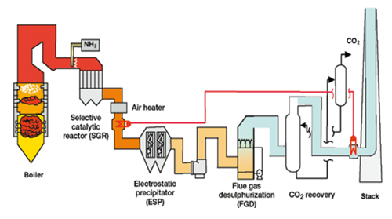

Figure 1: post combustion flue gas clean up PFD

Source: http://www.kbr.com/Technologies/Process-Technologies/Post-Combustion-Carbon-Capture/

**Absorption of CO2 and regeneration of solvent:**

The absorber utilized is typically a packed column, in which a packing that provides

Sufficient surface area for the absorption of CO2 is used. The flue gas enters at the bottom

of the absorber with the lean amine solvent entering at the top of the absorber. The lean

amine comes in at a loading of between 0.2- 0.3 and leaves at a loading close to 0.5. In a

MEA system, the loading is defined on a mole basis as given by mole of CO2 absorber per mole of MEA given.

In this case, lean amine refers to the amine stream that is stripped of CO2 i.e. the amine

stream that enters the top of the absorber. When the amine stream is loaded with CO2, as

is the case with the stream that leaves the bottom of the absorber, it is referred to as a rich

amine stream. The amine stream is usually introduced on the second stage from the top

with make-up water entering at the first stage. This allows the first stage to function as a

water wash to remove any entrained MEA that may be carried out along with the vent gas

that is stripped of CO2. It also serves the function of cooling the vent gas before it is

released to the atmosphere. In some cases, it may be necessary to have a separate water

wash tower after the absorber.

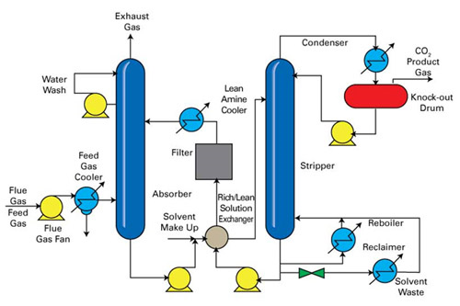

Figure 2: post combustion CO2 capture PFD

Source: http://www.kbr.com/Technologies/Process-Technologies/Post-Combustion-Carbon-Capture/

The rich amine leaves from the bottom of the absorber from where it is sent to a pump

before being sent to the cross-heat exchanger. In the cross heat-exchanger, the rich stream

from the absorber exchanges heat with the lean stream from the desorber. This allows the

rich stream to be heated and the lean stream to be cooled down. Before proceeding to the

absorber, the lean stream is further cooled to bring its temperature down to 40°C or so.

The rich stream is taken from the cross-heat exchanger to the desorber. The desorber is a

packed column that has a kettle reboiler. The desorber typically operates at slightly

elevated pressures (~1.5-1.8 atm). The rich amine enters at the second stage of the

desorber and flows down the column, counter to the direction of the vapors from the

reboiler. The stream from the top of the column is taken to a condenser in order to

condense the water and lower the temperature and then to a flash in order to separate the

CO2 and H2O. A part of the liquid reflux (pure water) is returned to the top of the

desorber column while a purge stream is sent to storage. As in the absorber, the first stage

in the desorber acts as a water wash stage to remove any entrained MEA in the vapor

leaving the top of the desorber. In the reboiler of the desorber, steam from the power

plant is used to produce the heat duty. The heat duty in the reboiler arises from three

different requirements:

1. Sensible heat to raise the temperature of the to that in the desorber

2. Heat of reaction to reverse the absorption reaction and release CO2

3. Heat to produce steam to maintain driving force for transfer of CO2 from liquid

phase to gas phase.

**Reclaiming of solvent:**

Particularly in the case of flue gas from coal fired power plants, it will be necessary to

use a MEA reclaimer to treat some of the heat stable salts that from due to the NOx and

SOx. The continued buildup of these salts in the amine stream is undesirable since it

lowers the capacity of the solvent for CO2 absorption. A purge stream of the solvent is

removed and taken to a reclaimer where in the presence of a strong alkali like NaOH and

with the application of heat, some of the heat stable salts can be dissociated, resulting in

the recovery of some of the solvent. The sludge that is produced in the reclaimer is sent

for disposal in a landfill.